**Question 1**

Display the data types of each column using the function dtypes. Take a screenshot of your code and output. You will need to submit the screenshot for the final project.

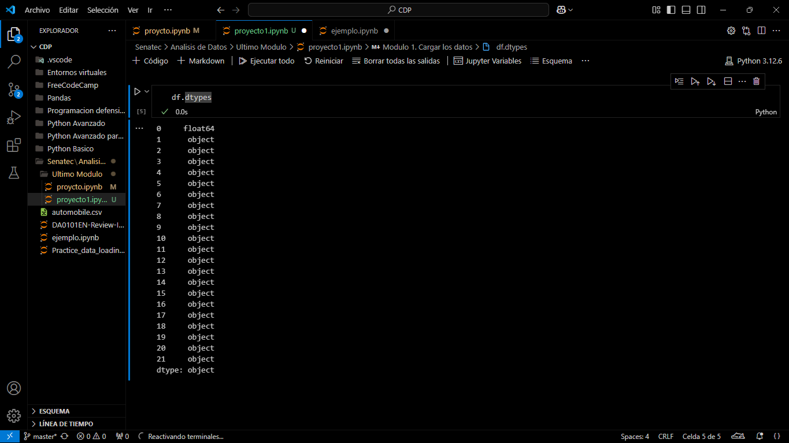

**Question 2**[**¶**](https://cf-courses-data.static.labs.skills.network/jupyterlite/2.5.5/lab/index.html?mode=learn&env_type=jupyterlite&notebook_url=https%3A%2F%2Fcf-courses-data.static.labs.skills.network%2FIBMDeveloperSkillsNetwork-DA0101EN-SkillsNetwork%2Flabs%2FModule_6%2FHouse_Sales_in_King_Count_USA-20231003-1696291200.jupyterlite.ipynb&file_path=DA0101EN%2Flabs%2FModule+6%2FHouse_Sales_in_King_Count_USA.ipynb#Question-2)

Drop the columns "id" and "Unnamed: 0" from axis 1 using the method drop(), then use the method describe() to obtain a statistical summary of the data. Make sure the inplace parameter is set to True. Take a screenshot of your code and output. You will need to submit the screenshot for the final project.

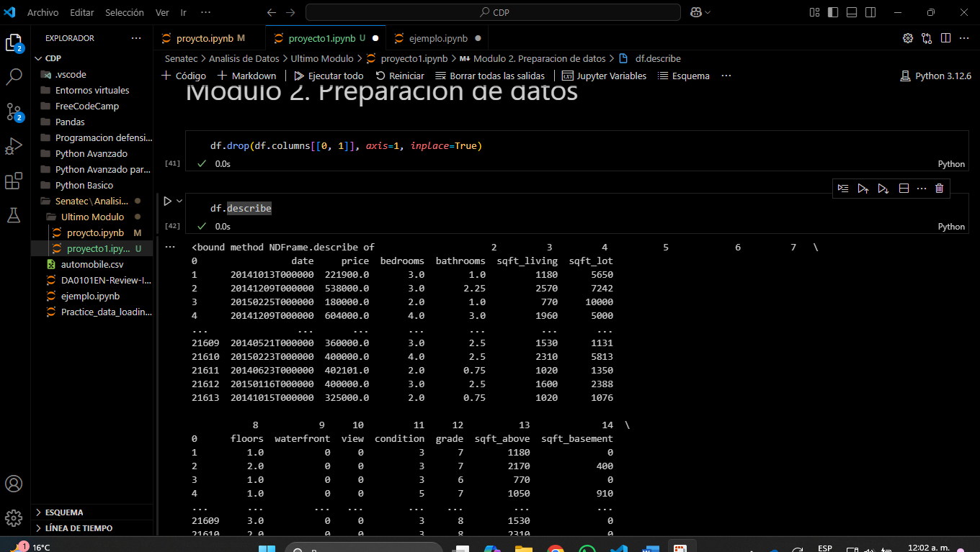

**Question 3**

Use the method value_counts to count the number of houses with unique floor values, use the method .to_frame() to convert it to a data frame. Take a screenshot of your code and output. You will need to submit the screenshot for the final project. 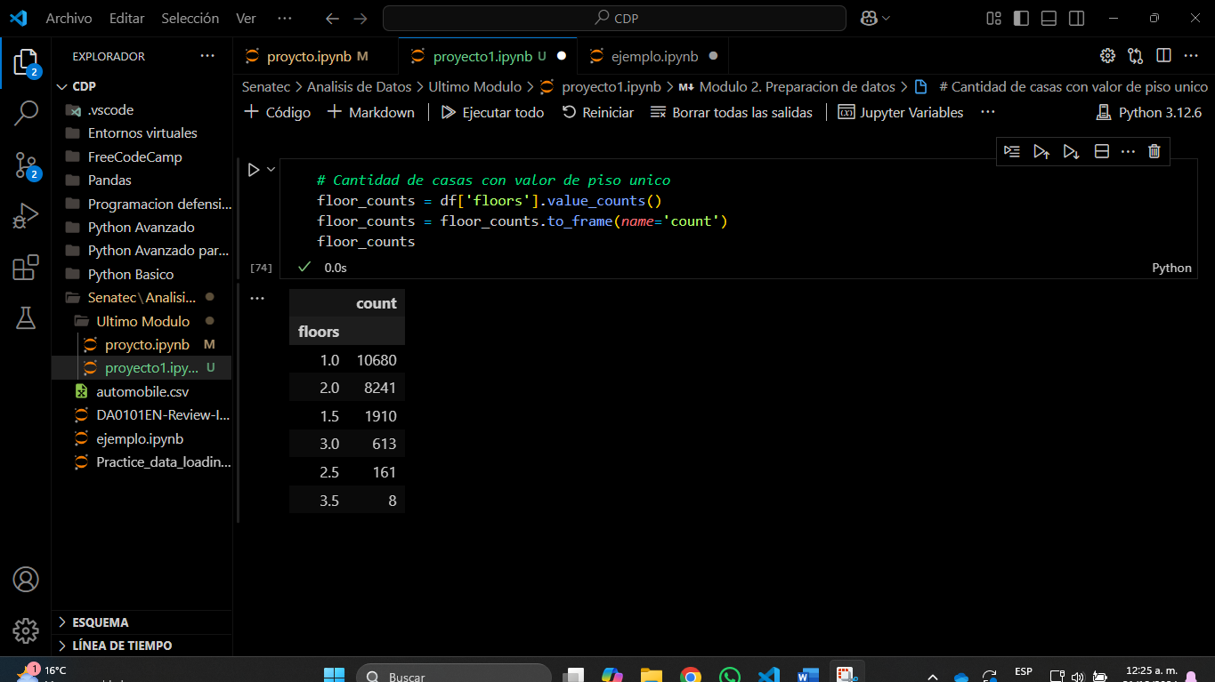

**Question 4**

Use the function boxplot in the seaborn library to determine whether houses with a waterfront view or without a waterfront view have more price outliers. Take a screenshot of your code and boxplot. You will need to submit the screenshot for the final project.

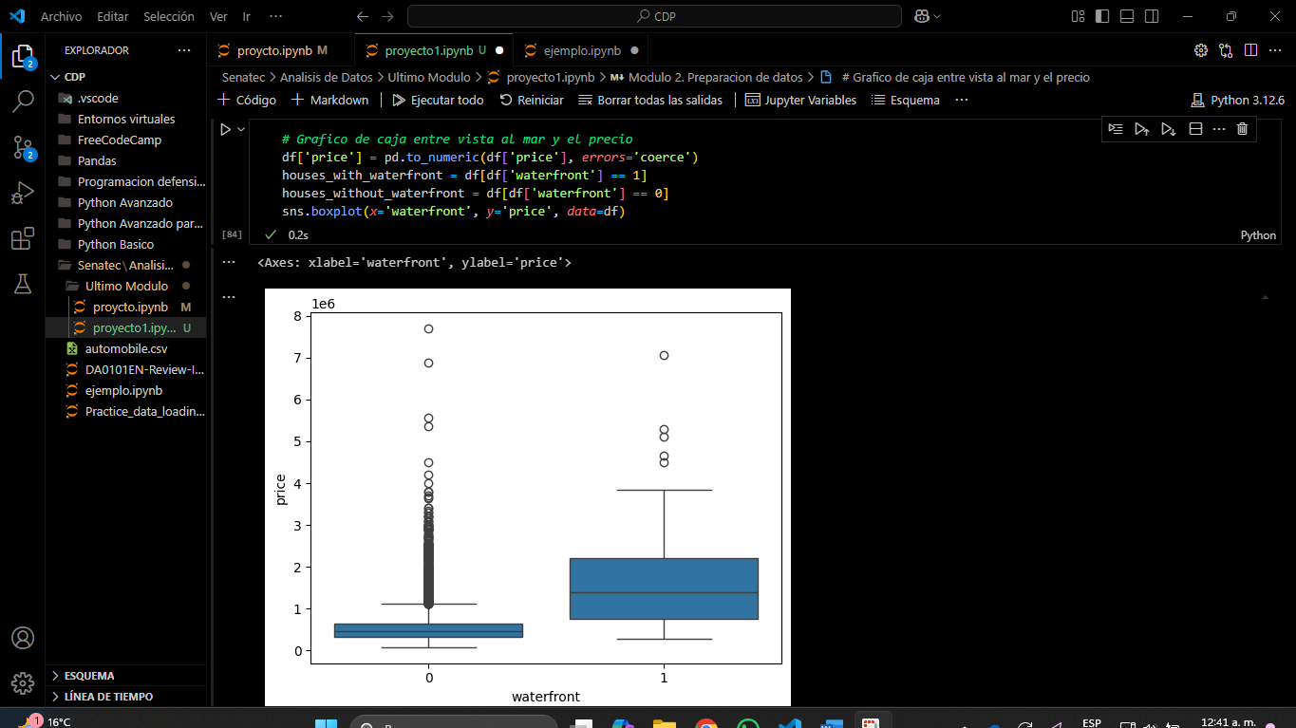

**Question 5**

Use the function regplot in the seaborn library to determine if the feature sqft_above is negatively or positively correlated with price. Take a screenshot of your code and scatterplot. You will need to submit the screenshot for the final project.

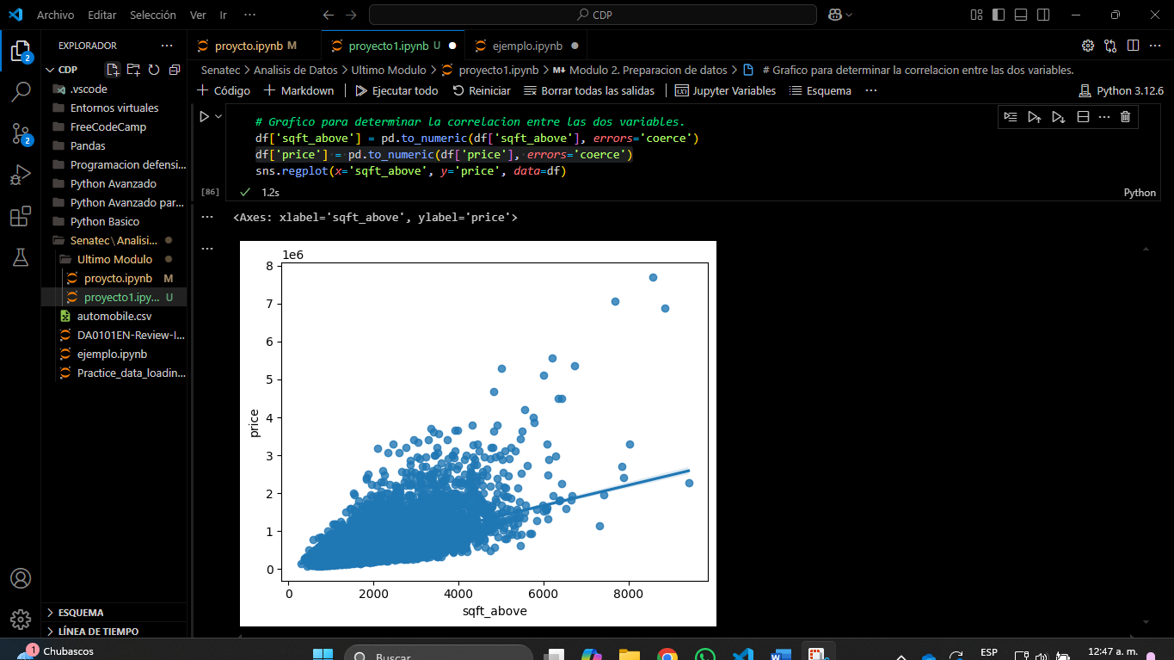

**Question 6**[**¶**](https://cf-courses-data.static.labs.skills.network/jupyterlite/2.5.5/lab/index.html?mode=learn&env_type=jupyterlite&notebook_url=https%3A%2F%2Fcf-courses-data.static.labs.skills.network%2FIBMDeveloperSkillsNetwork-DA0101EN-SkillsNetwork%2Flabs%2FModule_6%2FHouse_Sales_in_King_Count_USA-20231003-1696291200.jupyterlite.ipynb&file_path=DA0101EN%2Flabs%2FModule+6%2FHouse_Sales_in_King_Count_USA.ipynb#Question--6)

Fit a linear regression model to predict the 'price' using the feature 'sqft_living' then calculate the R^2. Take a screenshot of your code and the value of the R^2. You will need to submit it for the final project.

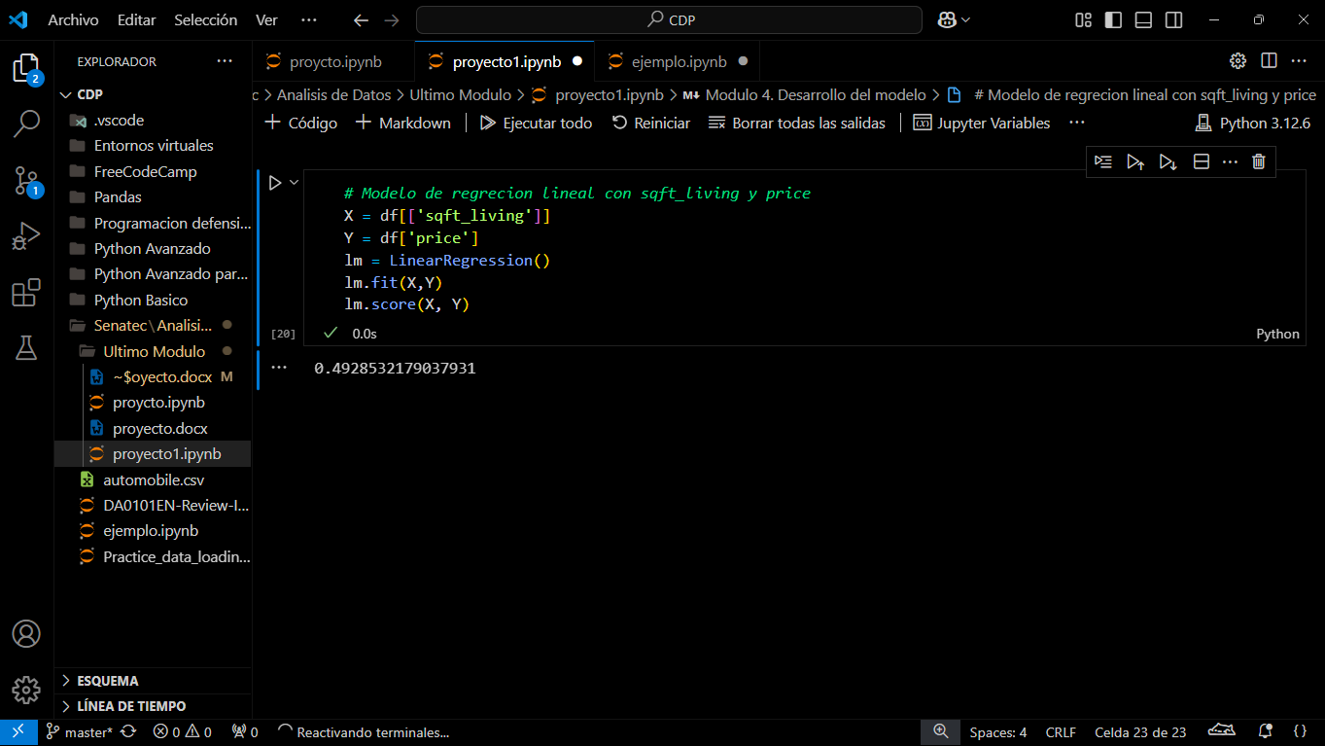

**Question 7**

Fit a linear regression model to predict the 'price' using the list of features:

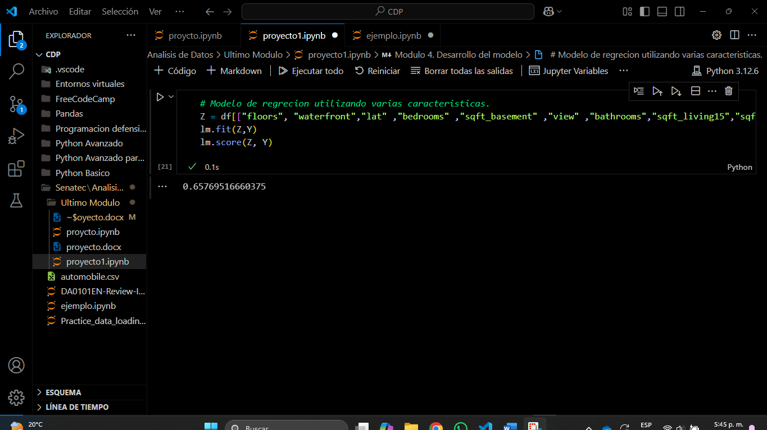

**Question 8**

Use the list to create a pipeline object to predict the 'price', fit the object using the features in the list features, and calculate the R^2. Take a screenshot of your code and the value of the R^2. You will need to submit it for the final project.

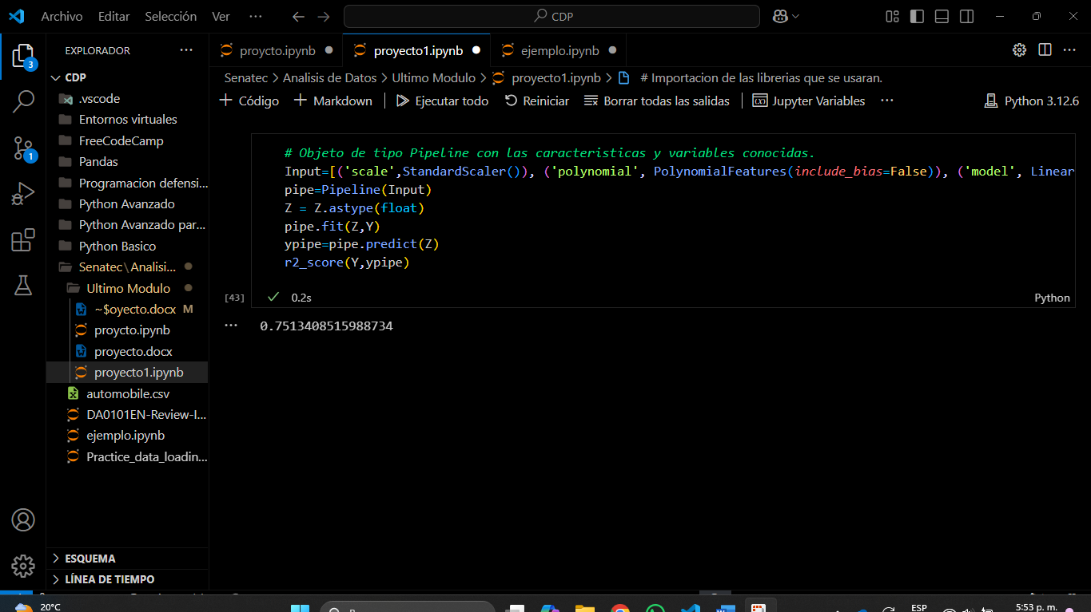

Question 9

Create and fit a Ridge regression object using the training data, set the regularization parameter to 0.1, and calculate the R^2 using the test data. Take a screenshot of your code and the value of the R^2. You will need to submit it for the final project.

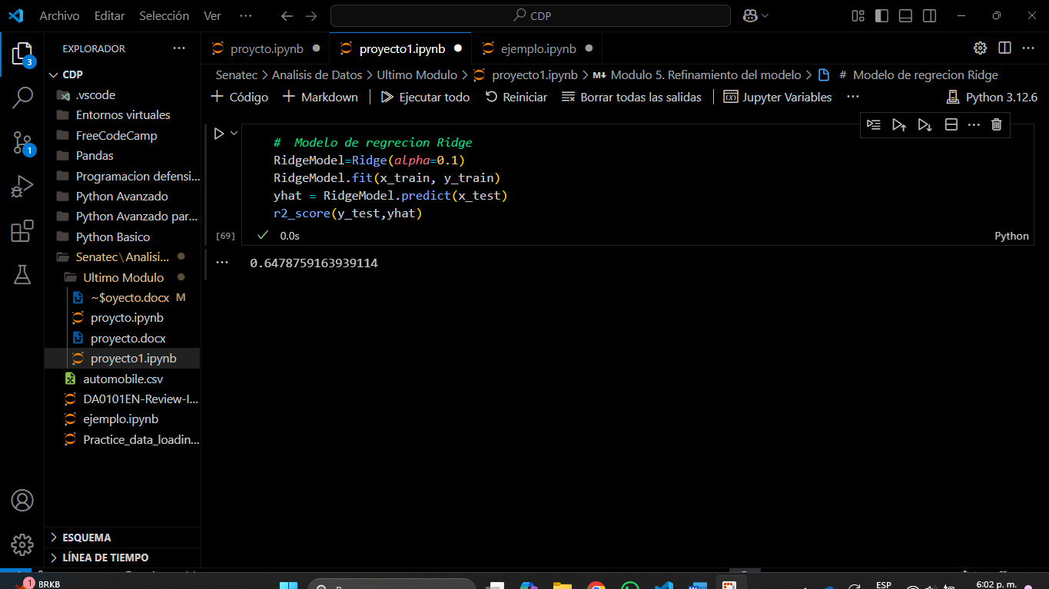

**Question 10**

Perform a second order polynomial transform on both the training data and testing data. Create and fit a Ridge regression object using the training data, set the regularisation parameter to 0.1, and calculate the R^2 utilising the test data provided. Take a screenshot of your code and the R^2. You will need to submit it for the final project.